Experiment No.: 8

2:1 MULTIPLEXER

AIM: To prepare CMOS layout in selected technology for 2:1 multiplexer using logic gates and transmission gates.

PREREQUISITE:
Students should know the constructs of microwind.

OBJECTIVES:
- To design 2:1 Mux by conventional method and by using Transmission gates
- Comparison of them.
- To simulate the design in DSCH and microwind.

TOOLS USED:
- Microwind software with version 3 and above.

PROBLEM STATEMENT:

Design 2:1 Mux by conventional method and by using Transmission gates, compare them, prepare layout in multi metal layers and simulate

THEORY:

Transmission Gate:

A PMOS or NMOS transistor alone is (an imperfect switch) called as pass transistor. An NMOS transistor passes a strong „0‟ since it is almost perfect switch when passing a „0‟,But it is imperfect at passing „1‟.A PMOS transistor has opposite behavior i.e. passing a strong „1‟s and degraded „0 ‟s. Parallel combination of NMOS & PMOS transistor is called as transmission gates.
The transmission gate turns on when a „1‟ is applied to G in which „0‟s & „1‟s are both passed in acceptable form. the control signal (G) is applied to NMOS transistor & its complementary (6 B) is applied to PMOS & NMOS transistor are ON & provides a law resistance path between terminal A &
B. Transmission gate is used as bidirectional switch controlled by control signal (G).

ADYPSOE/E&TC/LAB MANUAL

SYMBOL:
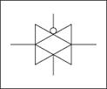

Fig.1.Symbol of Transmission gate

2:1 Multiplexer:

A multiplexer is a digital circuit which selects one of the n data inputs & routes it to output. The selection is done by select I/P to select n I/Ps we need m select lines such that 2m = n. 2:1 multiplexer consist of 2 data inputs D0 &D1, one select I/p & output.
Boolean Equation for 2:1 Mux:
C=A+SB
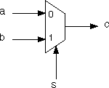

Fig.2. Symbol of 2:1 Multiplexer

Construction using Transmission Gate:

Two I/p multiplexer can be & allowed by connecting two transmission gate together as shown in figures. Any one of transmission gate is enabled depending on select lines.

ADYPSOE/E&TC/LAB MANUAL 59

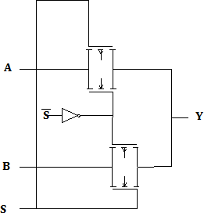
Fig.3) 2:1 Mux. using Transmission Gate

Truth Table for 2:1 Mux. Using Transmission Gate:

 | TG 1 | TG 2 | Y
S=0 | OFF | ON | A
S=1 | ON | OFF | B

Comparison of implementation of 2:1 MUX using transmission gate and conventional method:

Implementation through the conventional method required a total of 20 transistors, whereas implementing 2:1 MUX using transmission gate requires only four transistors.

PROCEDURE:

- Select foundry.
- Calculate W/L ratio for given design.
- Select NMOS from palette with calculated width and length.
- Select PMOS from palette with calculated width and length.
- Join the Gates of PMOS & NMOS, label the inputs.
- Connect sources of PMOS to VDD rail and source of NMOS to GND rail with metal.
- Make the connections as per the lay out with metal.
- Run DRC & correct the errors if any.
- Run Simulation and verify the output waveforms.

2:1 MULTIPLEXER DESIGN:

Fig.4. 2:1 Multiplexer

2:1 MULTIPLEXER OUTPUT WAVEFORM

Fig.5.Output waveform of 2:1 Multiplexer

CONCLUSION:

ADYPSOE/E&TC/LAB MANUAL

